**Queries and Results ScreenShot**

**Query 1: Group by Month and Year**

SELECT

EXTRACT(YEAR FROM Date) AS Year,

EXTRACT(MONTH FROM Date) AS Month,

SUM(Total_Revenue) AS Monthly_Revenue,

COUNT(DISTINCT Transaction_ID) AS Order_Volume

FROM sales_data

GROUP BY

Year, Month

ORDER BY

Year, Month;

**Result:**

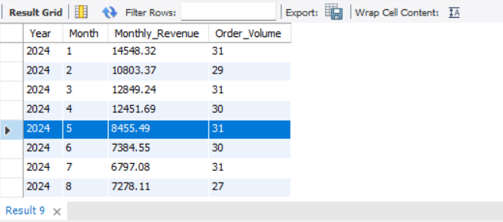

**Objective:** Analyze monthly revenue and order volume.

**Insights:**

* **Seasonal Trends:** The results reveal how revenue and order volume vary across months and years. For example, certain months may show a spike in sales due to holiday seasons or special events.
* **Consistency:** Periods with stable or consistent order volumes suggest steady customer demand, while fluctuations indicate specific factors (e.g., promotions or external events) driving sales.

**Query 2: Top 3 Months by Sales**

SELECT

EXTRACT(YEAR FROM Date) AS Year,

EXTRACT(MONTH FROM Date) AS Month,

SUM(Total_Revenue) AS Monthly_Revenue

FROM

sales_data

GROUP BY

Year, Month

ORDER BY

Monthly_Revenue DESC

LIMIT 3;

**Result**

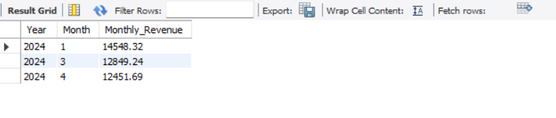

**Objective:** Identify the highest revenue-generating months.

**Insights:**

* Peak Months: The top 3 months highlight periods of peak sales, possibly driven by seasonal events, festivals, or promotions.
* Actionable Conclusion: Focus marketing efforts and inventory on these months to capitalize on high demand.

**Query 3: Order Volume and Revenue by Product Category**

**This query calculates total revenue and order volume for each product category and sorts them by revenue in descending order:**

SELECT

Product_Category,

SUM(Total_Revenue) AS Total_Revenue,

COUNT(DISTINCT Transaction_ID) AS Order_Volume

FROM

sales_data

GROUP BY

Product_Category

ORDER BY

Total_Revenue DESC;

**Result**

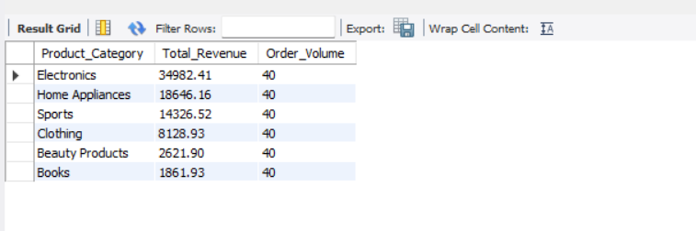

**Objective:** Understand revenue and transaction volume by category.

**Insights:**

* **Top Categories:** Electronics likely dominate revenue, followed by other high-ticket categories such as Home Appliances or Fitness.
* **Balance:** Categories with moderate revenue but high order volumes (e.g., Beauty Products) indicate affordability and consistent demand.
* **Recommendation:** Expand inventory in top-performing categories or launch targeted promotions for mid-tier ones.

**Query 4: Filter Data for Specific Time Periods**

**Let’s focus on analyzing revenue and order volume for January 2024 as an example.**

SELECT

EXTRACT(YEAR FROM Date) AS Year,

EXTRACT(MONTH FROM Date) AS Month,

SUM(Total_Revenue) AS Monthly_Revenue,

COUNT(DISTINCT Transaction_ID) AS Order_Volume

FROM

sales_data

WHERE

Date BETWEEN '2024-01-01' AND '2024-01-31'

GROUP BY

Year, Month

ORDER BY

Year, Month;

**Result**

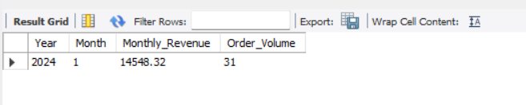

**Objective:** Analyze sales trends for January 2024.

**Insights:**

* **Seasonal Impact:** January often reflects post-holiday sales trends or new year resolutions (e.g., demand for fitness or electronics).
* **Revenue Stability:** High revenue combined with consistent order volume suggests steady demand during this period.

**Query 5: Revenue Trends by Product**

SELECT

Product_Name,

SUM(Total_Revenue) AS Total_Revenue,

COUNT(DISTINCT Transaction_ID) AS Order_Volume

FROM

sales_data

GROUP BY

Product_Name

ORDER BY

Total_Revenue DESC;

**Result**

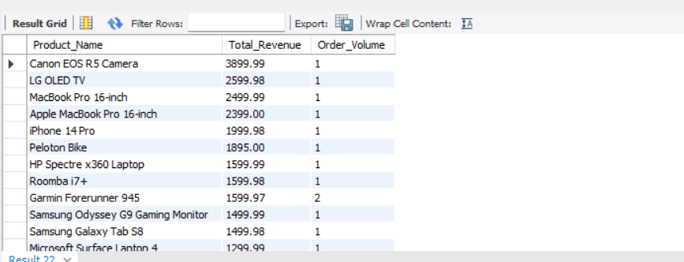

**Objective:** Identify top revenue-generating products.

**Insights:**

* **Best-Sellers:** High-ticket items (e.g., MacBook Pro, iPhone) likely top the list, contributing significant revenue despite lower order volumes.
* **Opportunities:** Mid-range products with decent sales offer opportunities for bundling or targeted promotions.

**Query 6: Revenue Trends by Product Over Time**

**Here’s a query to calculate monthly revenue for each product:**

SELECT

EXTRACT(YEAR FROM Date) AS Year,

EXTRACT(MONTH FROM Date) AS Month,

Product_Name,

SUM(Total_Revenue) AS Monthly_Revenue

FROM

sales_data

GROUP BY

Year, Month, Product_Name

ORDER BY

Year, Month, Monthly_Revenue DESC;

**Result**

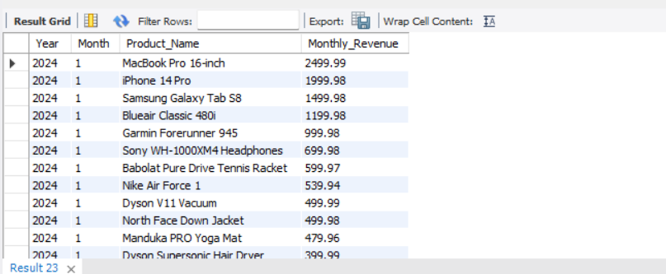

**Objective:** Analyze revenue trends for each product across months.

**Insights:**

* **Seasonal Performance:** Products like electronics may show spikes during holiday months, while fitness products might perform better at the start of the year.
* **Longevity:** Consistently high revenue over multiple months suggests flagship products, while one-time spikes could indicate seasonal interest.

**Query 7: Top Products Within Each Category**

**This query breaks down revenue by product and category:**

SELECT

Product_Category,

Product_Name,

SUM(Total_Revenue) AS Total_Revenue,

COUNT(DISTINCT Transaction_ID) AS Order_Volume

FROM

sales_data

GROUP BY

Product_Category, Product_Name

ORDER BY

Product_Category, Total_Revenue DESC;

**Result**

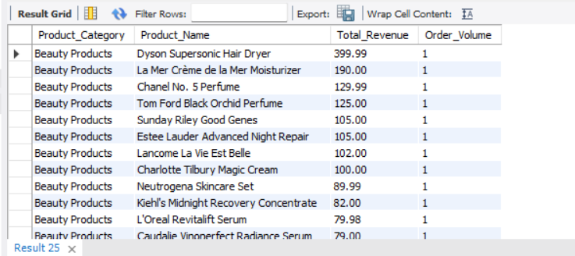

**Objective:** Break down revenue and order volume for products within categories.

**Insights:**

* **Category Leaders:** Products like Dyson Supersonic Hair Dryer (Beauty) and MacBook Pro (Electronics) dominate their respective categories.
* **Diverse Portfolio:** Categories with varied price ranges attract a broader customer base.
* **Recommendation:** Focus on promoting top products in each category and cross-sell mid-tier products to maximize revenue.

**Overall Insights**

1. **Seasonal Strategies:** Revenue peaks suggest the need for focused marketing during specific months.
2. **Product Mix:** High-ticket items drive revenue, but consistent demand for mid-tier products ensures stability.
3. **Category Focus:** Electronics and high-end products dominate, while accessible categories like Beauty offer consistent sales.